1- Assumptions

Assumptions:

Assumption 1: Patient Health Records Association

Assumption: Each patient can have multiple health records, and there is a one-to-many relationship between patients and health records.

Reasoning: The design includes a HealthRecord table with a foreign key referencing the Patient table.

Assumption 2: Medications Association

Assumption: Nurses can administer multiple medications to multiple patients, and there is a many-to-many relationship between nurses and patients through the Medication table.

Reasoning: The Medication table has foreign keys referencing both the Nurse and Patient tables.

Assumption 3: Room Occupancy Logic

Assumption: Room occupancy is calculated based on the presence of patients in the room.

Reasoning: The RoomOccupancyView is created to provide a dynamic view of room occupancy based on patient records.

2- (E)ERD

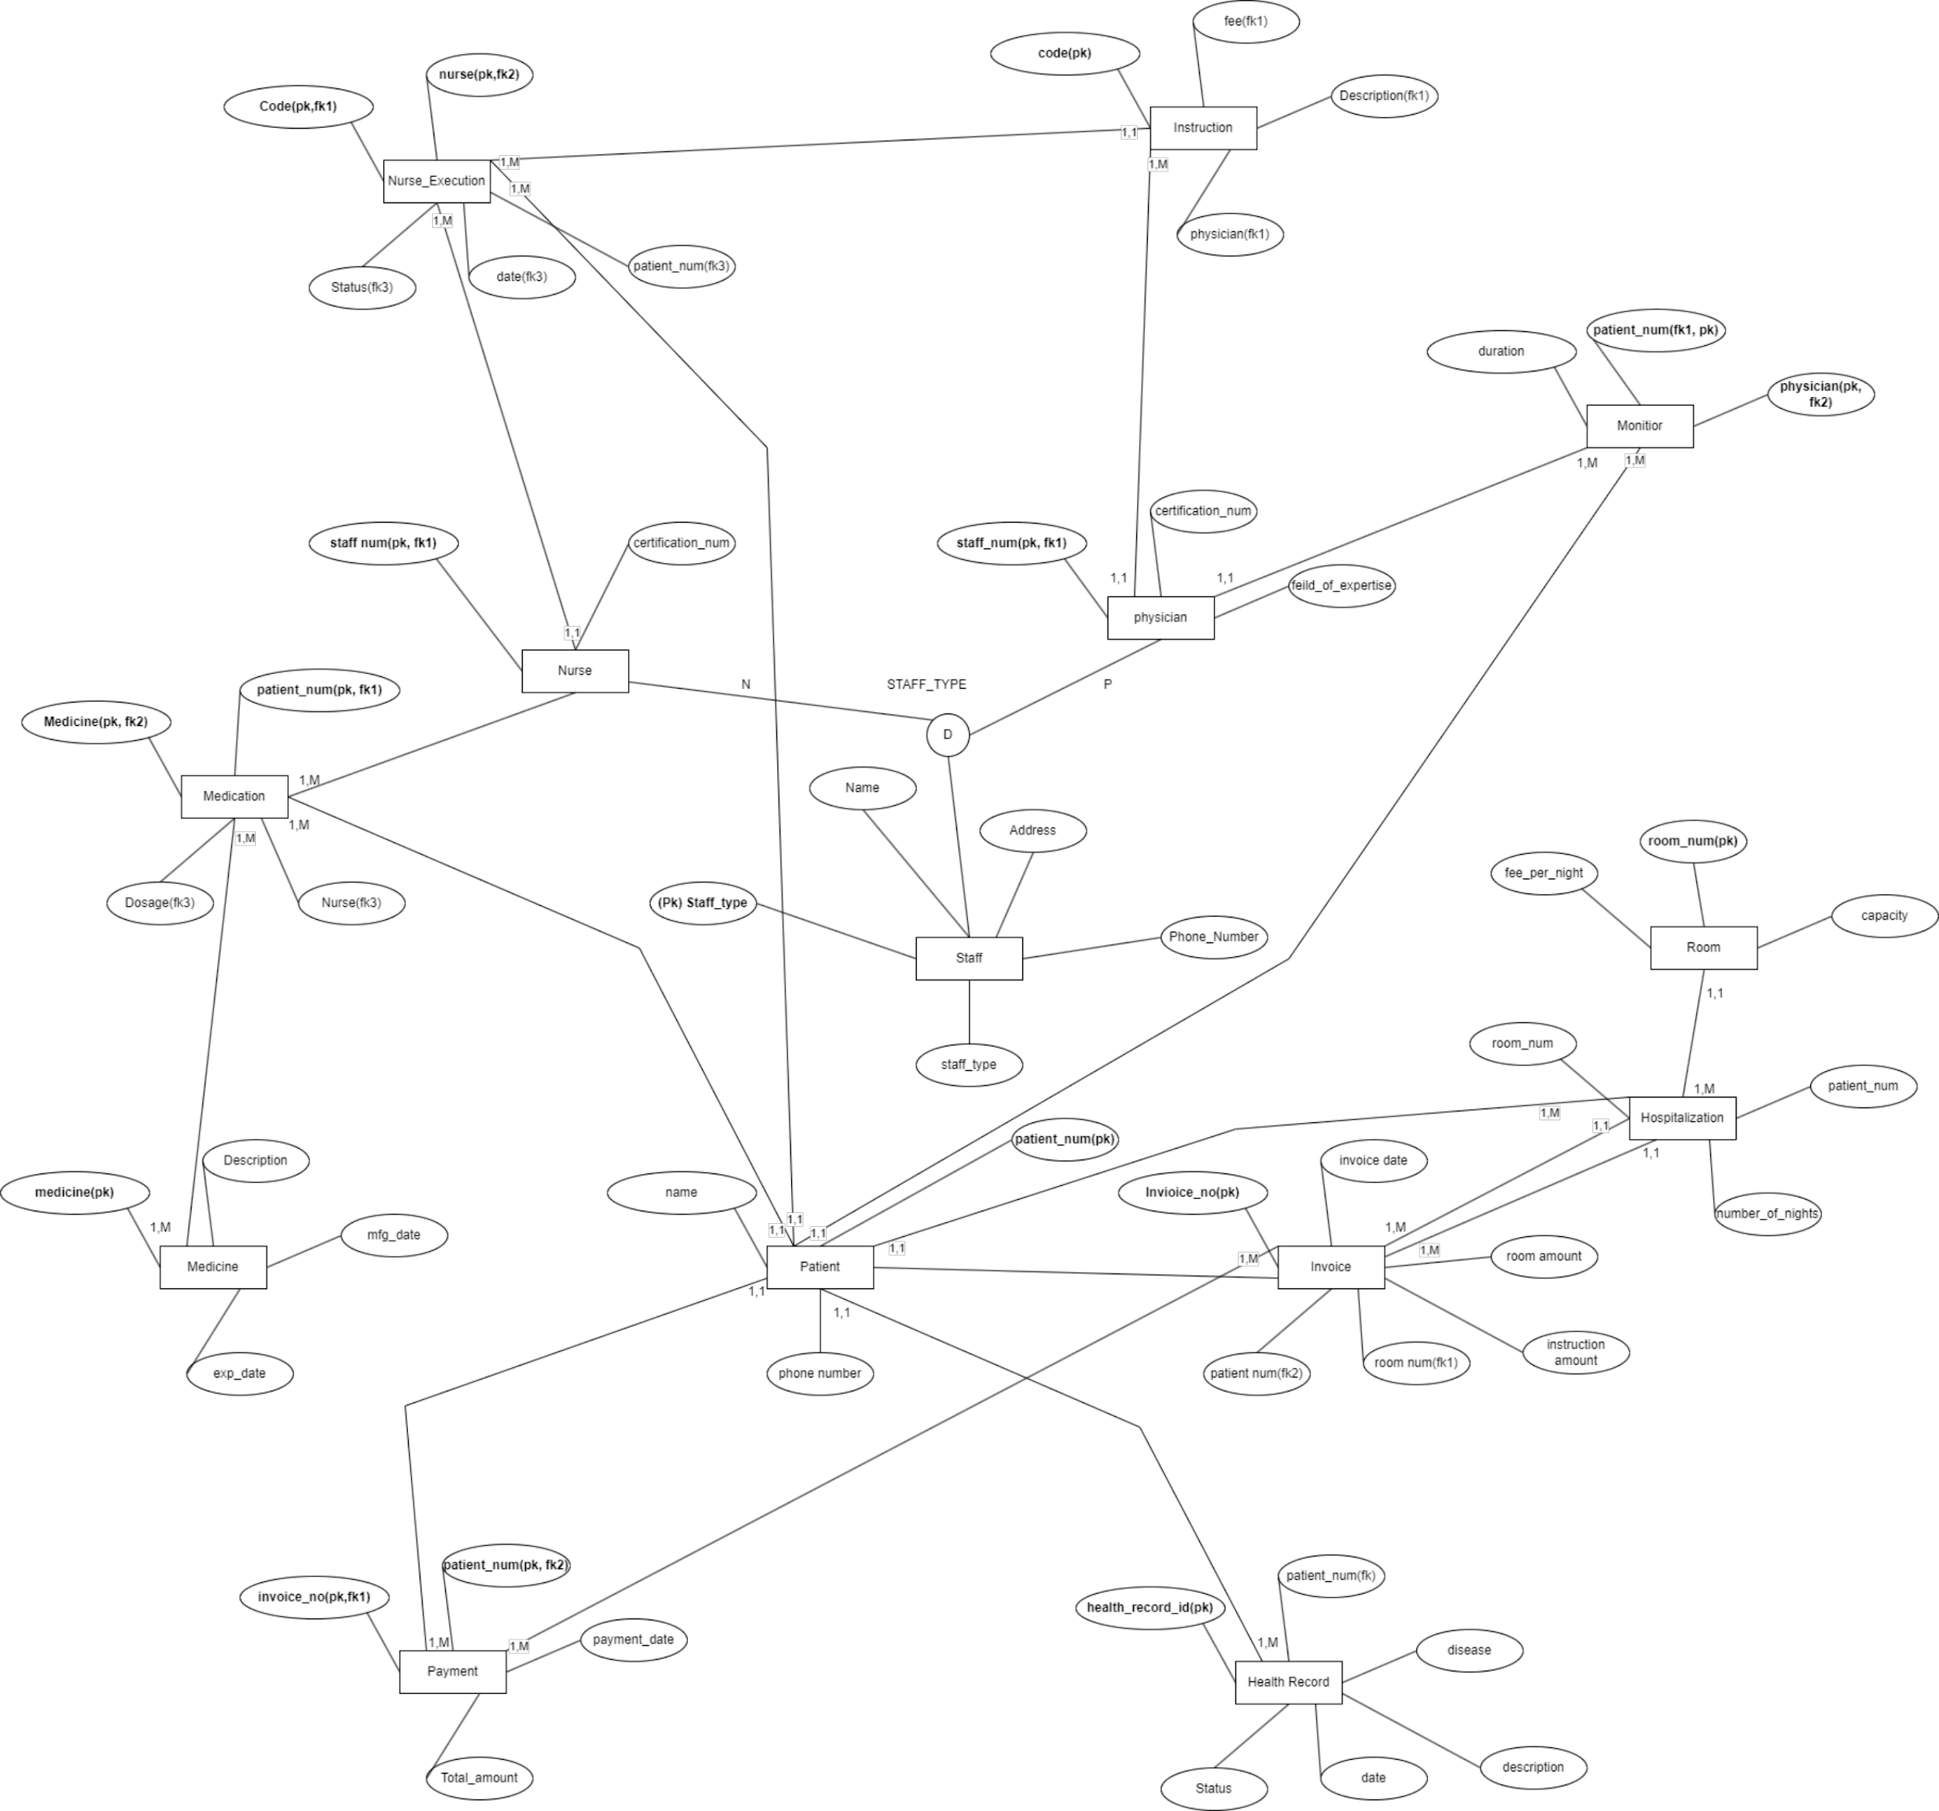

3- Relations and keys

Relation Physician:

Attributes: Physician_id, Name, Field_of_expertise, address, Certificate_No, Phone_number

Primary Key: {Physician_id}

Relation Rooms:

Attributes: Room_id, Fee_per_night, Capacity

Primary Key: {Room_id}

Relation Patient:

Attributes: Patient_id, Phone_number, Address, Name, Rooms_Room_id

Primary Key: {Patient_id}

Foreign Key: {Rooms_Room_id references Rooms(Room_id)}

Relation HealthRecord:

Attributes: Patient_id, status, Date, description, Disease, Patient_Patient_id

Primary Key: {Patient_id}

Foreign Key: {Patient_Patient_id references Patient(Patient_id)}

Relation Nurse:

Attributes: Nurse_id, Name, Certificate_number, phone_number, address, Physician_Physician_id

Primary Key: {Nurse_id}

Foreign Key: {Physician_Physician_id references Physician(Physician_id)}

Relation Payment:

Attributes: Patient_id, date, amount, Patient_Patient_id, Rooms_Room_id

Primary Key: {Patient_id}

Foreign Keys: {Patient_Patient_id references Patient(Patient_id), Rooms_Room_id references Rooms(Room_id)}

Relation Instruction:

Attributes: Instruction_id, execution_status, Fee, Description, Payment_Patient_id

Primary Key: {Instruction_id}

Foreign Key: {Payment_Patient_id references Payment(Patient_id)}

Relation Medication (assuming this should be corrected to Medication):

Attributes: Nurse_Nurse_id, Patient_Patient_id, Name, Quantity

Primary Key: {Nurse_Nurse_id, Patient_Patient_id}

Foreign Keys: {Nurse_Nurse_id references Nurse(Nurse_id), Patient_Patient_id references Patient(Patient_id)}

Relation Physician_has_Patient:

Attributes: Physician_Physician_id, Patient_Patient_id

Primary Key: {Physician_Physician_id, Patient_Patient_id}

Foreign Keys: {Physician_Physician_id references Physician(Physician_id), Patient_Patient_id references Patient(Patient_id)}

4. Views and description

Views:

PhysicianPatientView:

Description: This view displays the association between physicians and their assigned patients, including patient names.

Body: A join of Physician, Physician_has_Patient, and Patient tables.

Usefulness Discussion: Useful for quick access to the patient-physician association without

directly querying the join tables.

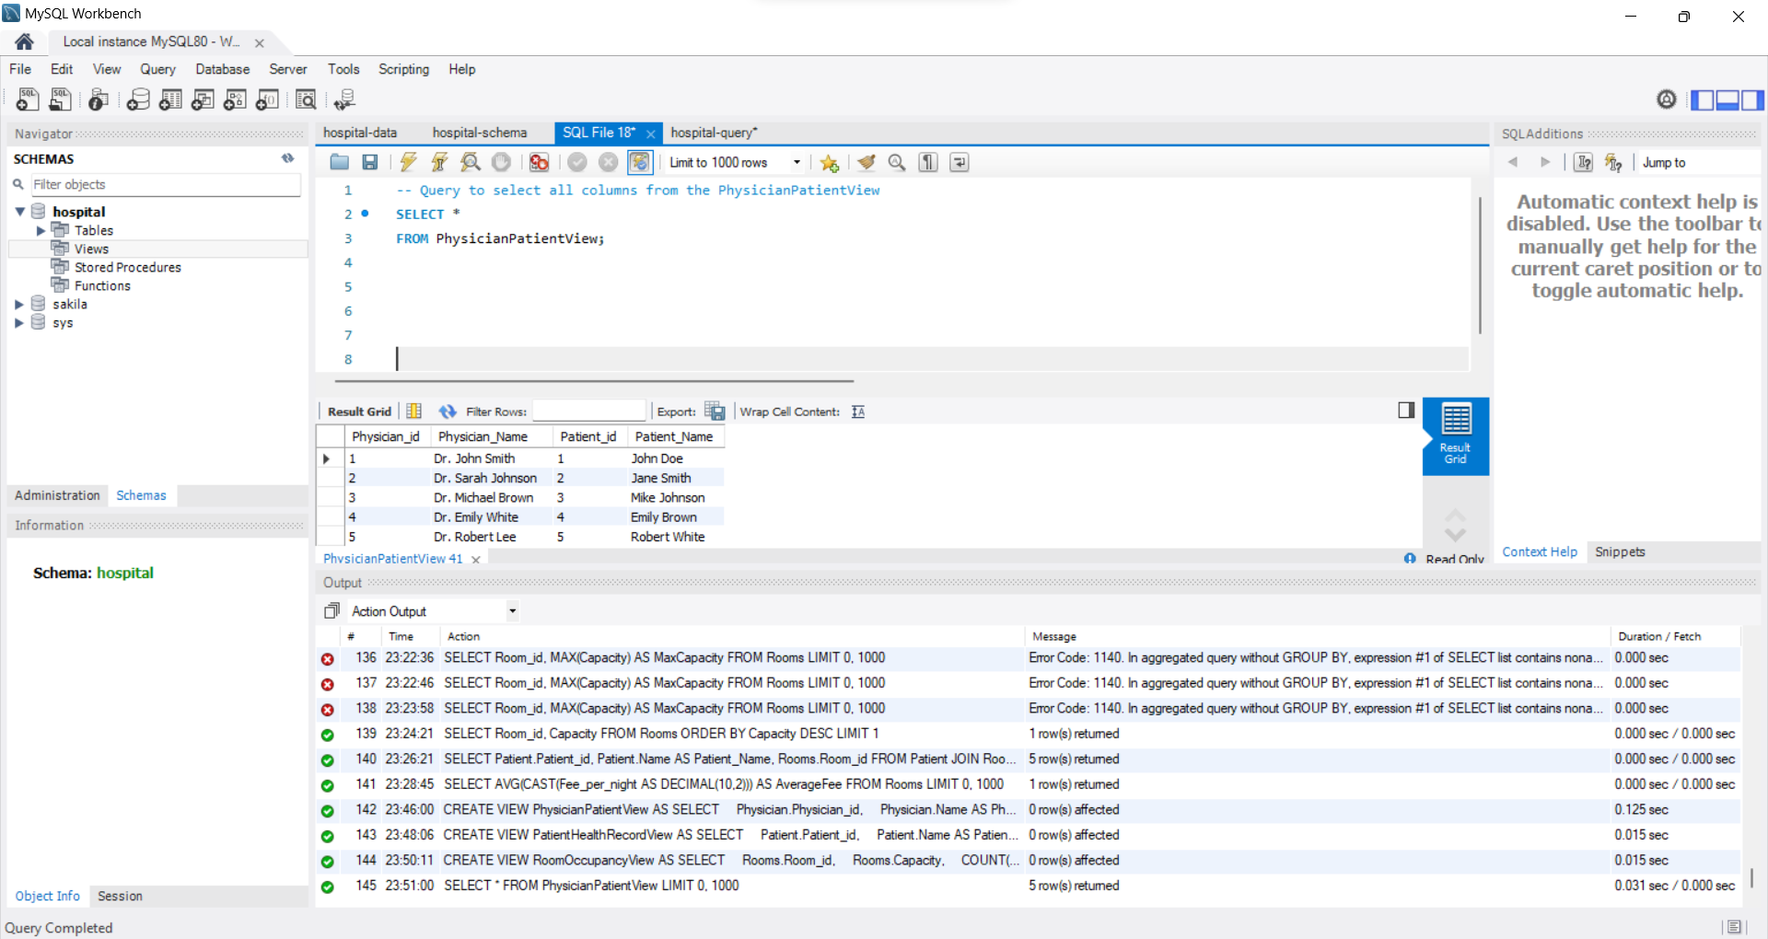

PatientHealthRecordView:

Description: This view shows patients and their associated health records, including status, description, and disease.

Body: A join of Patient and HealthRecord tables.

Usefulness Discussion: Helpful for obtaining a comprehensive view of patient health records in one query.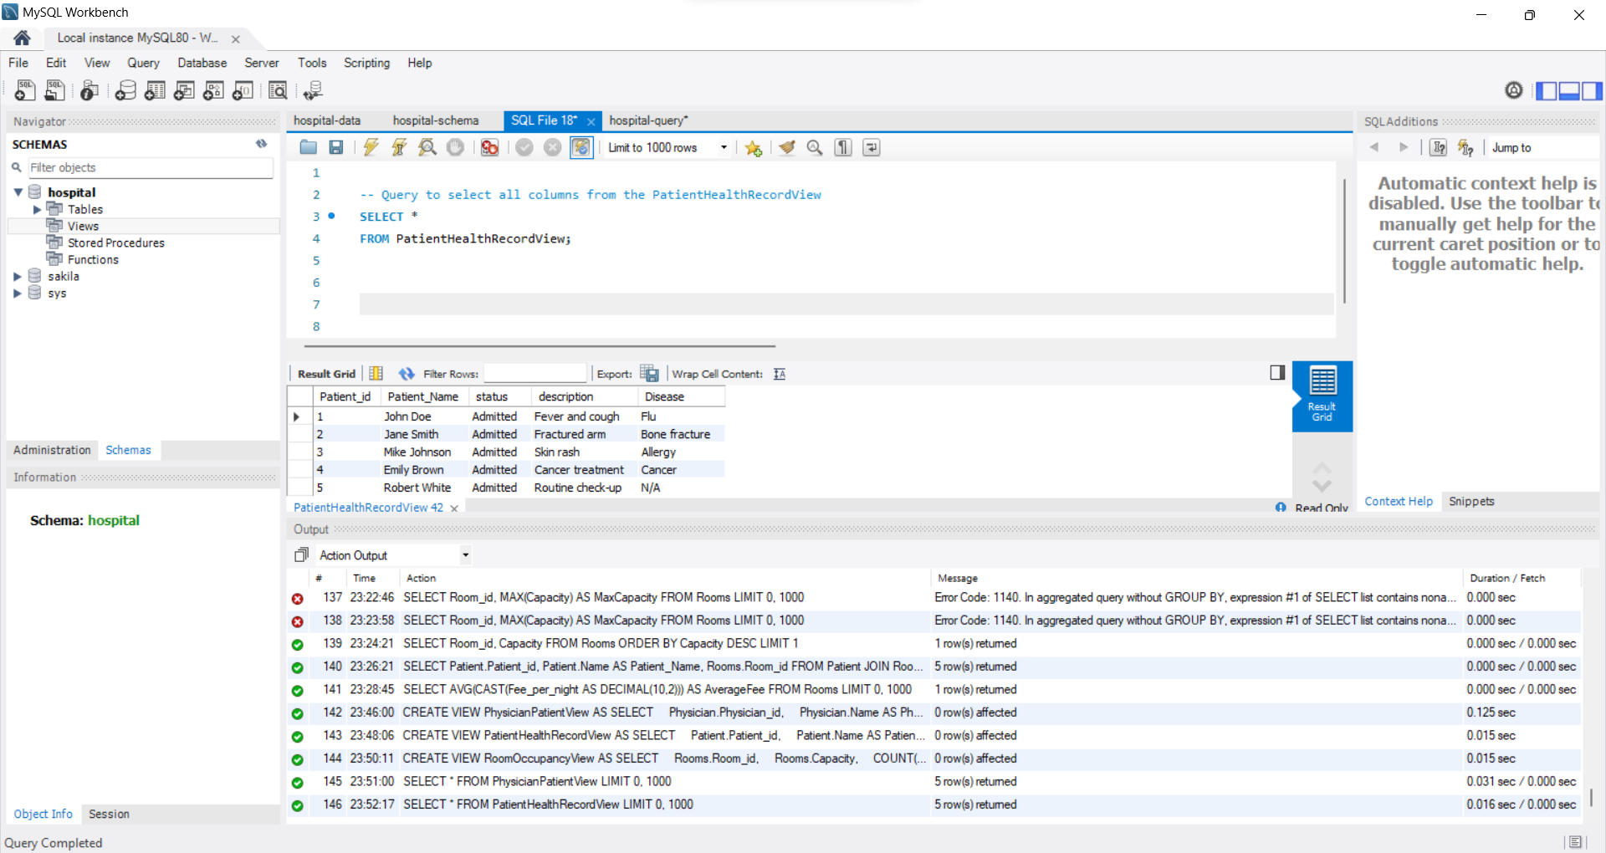

RoomOccupancyView:

Description: Displays room occupancy, showing the room ID, its capacity, and the number of currently occupied beds.Body: A join of Rooms and Patient tables with aggregation to count occupied beds.

Usefulness Discussion: Offers a quick overview of current room occupancy status.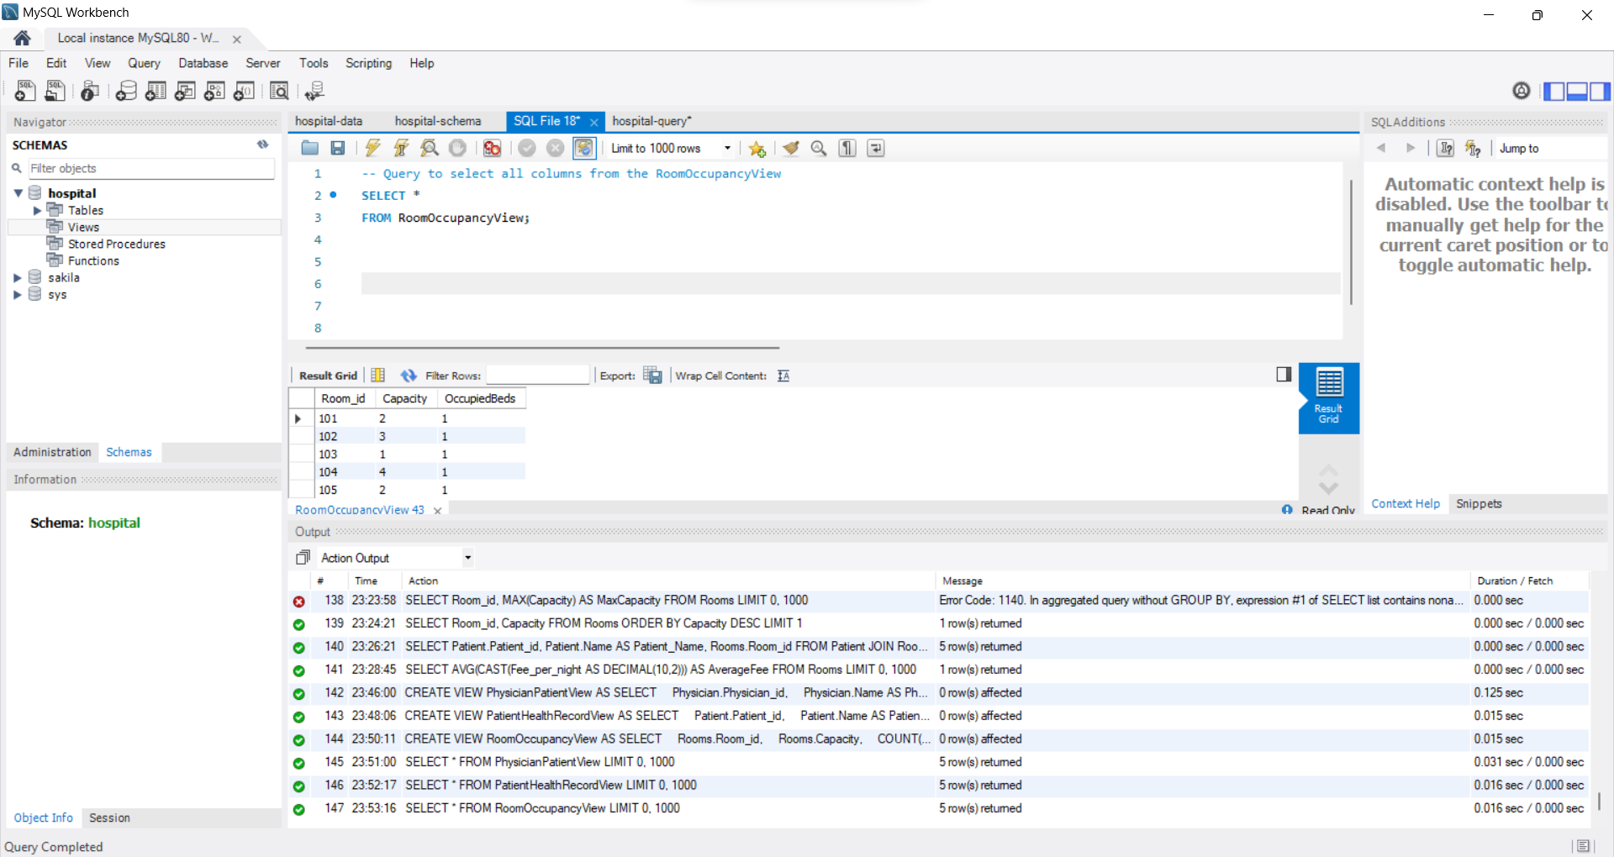

5- Triggers and description

Triggers:

InsertPatientTrigger:

Description: Updates RoomOccupancyView after a new patient is admitted.

Body: After insert trigger updating the RoomOccupancyView.

Usefulness Discussion: Ensures real-time monitoring of room occupancy without the need for separate queries.

DeletePatientTrigger:

Description: Updates RoomOccupancyView after a patient is discharged.

Body: After delete trigger updating the RoomOccupancyView.

Usefulness Discussion: Keeps room occupancy information up-to-date when patients are discharged.

HealthRecordUpdateTrigger:

Description: Updates PatientHealthRecordView after a health record is modified.

Body: After update trigger updating the PatientHealthRecordView.

Usefulness Discussion: Maintains consistency in the PatientHealthRecordView after any changes in health records.

6-Queries, descriptions, and results.

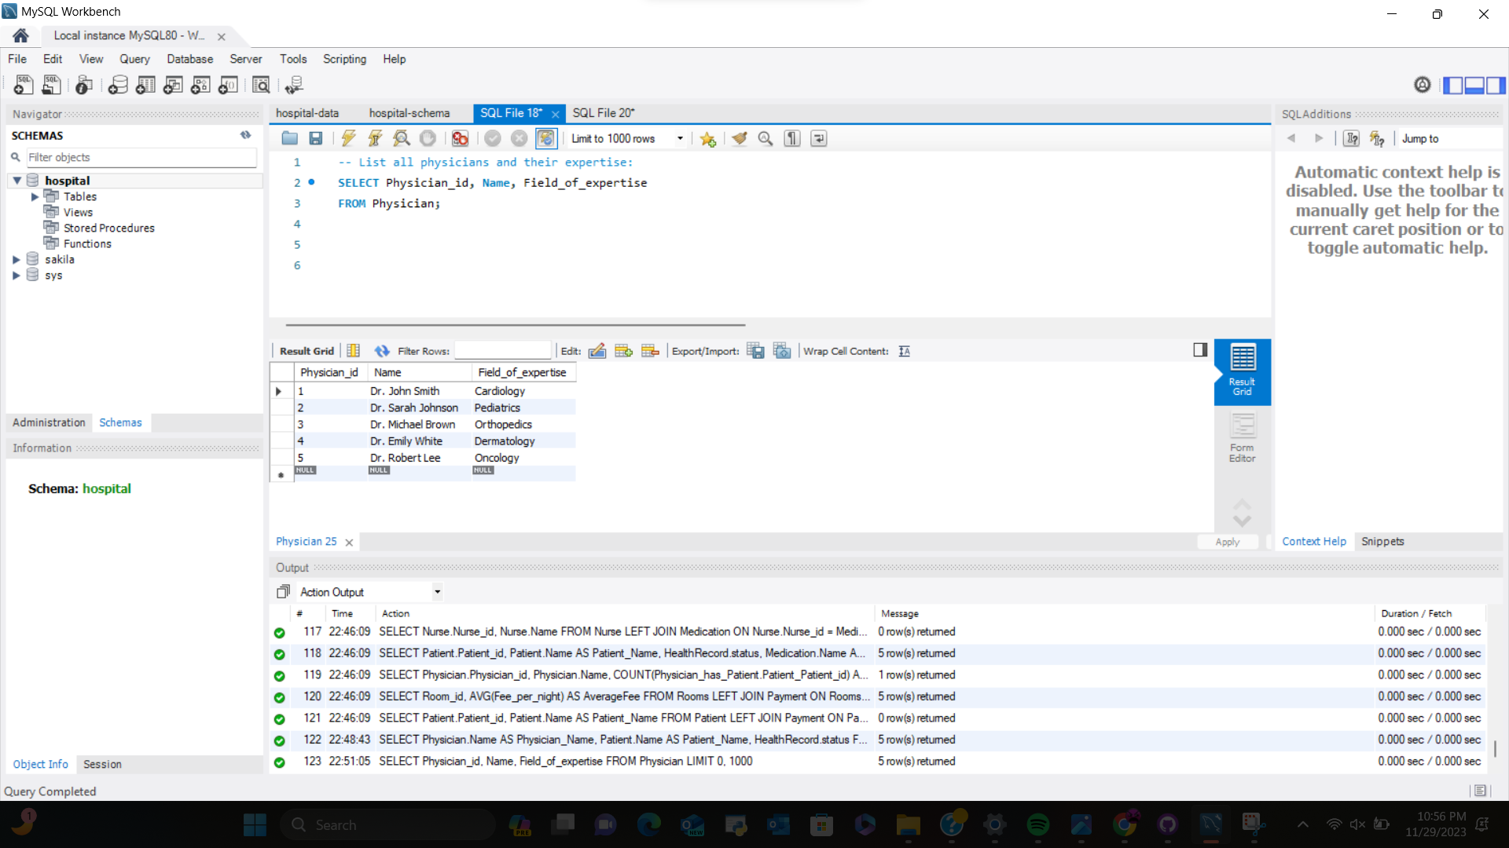

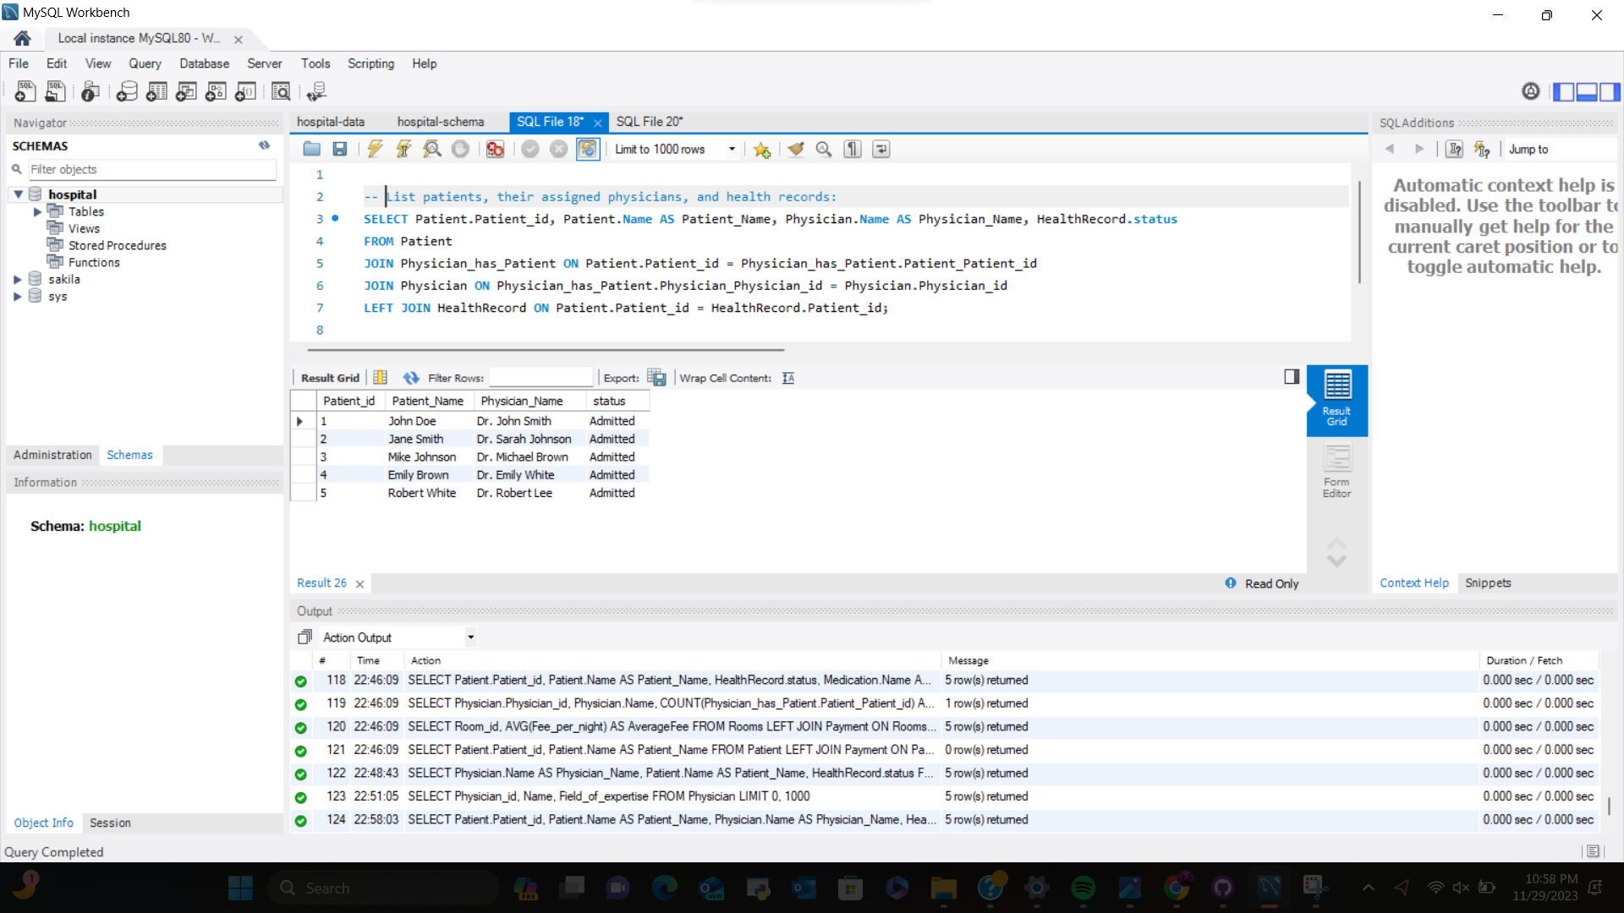

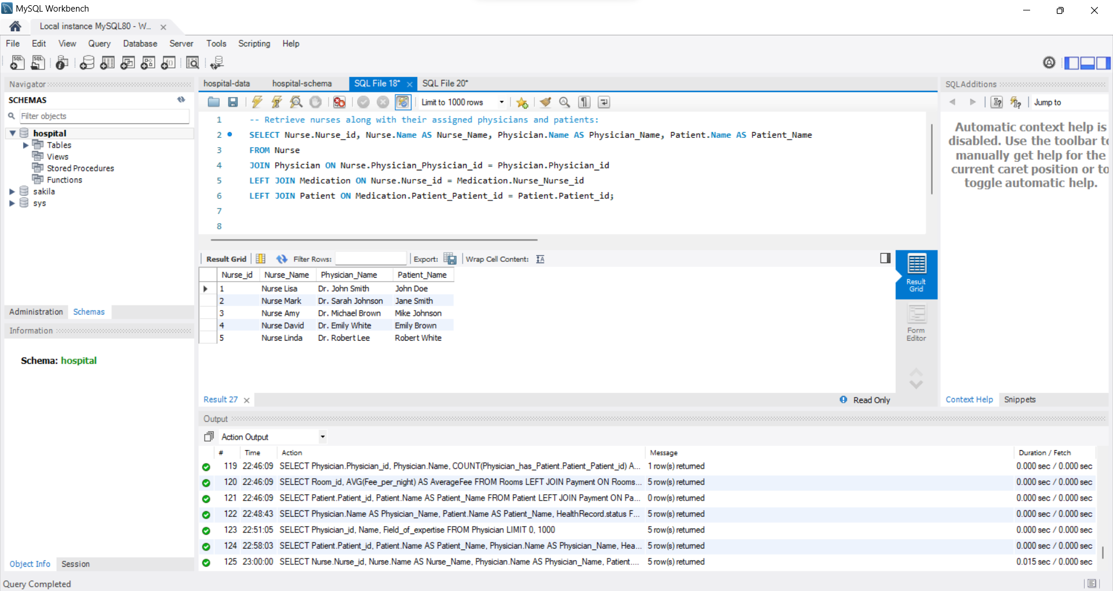

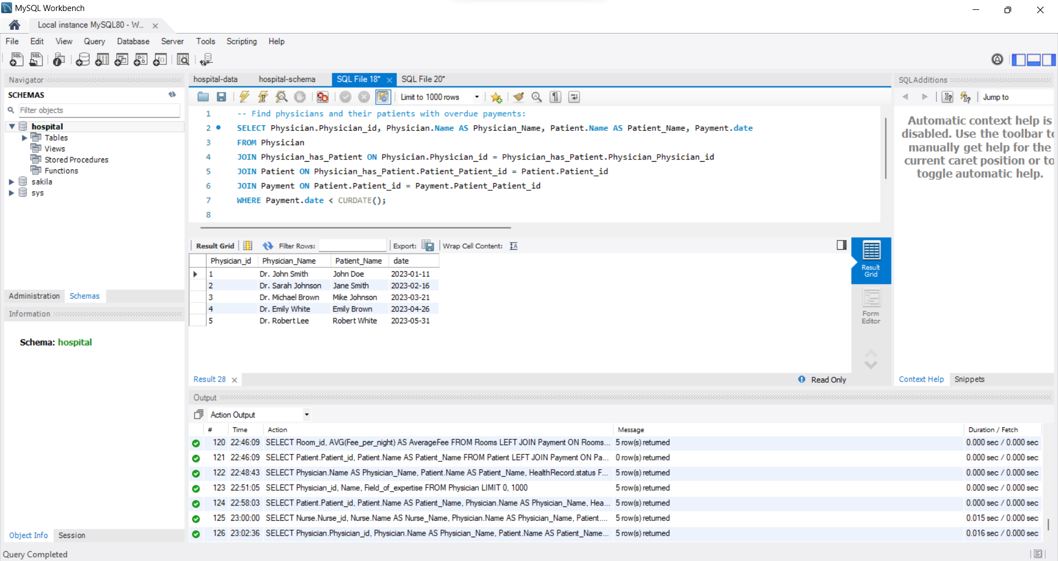

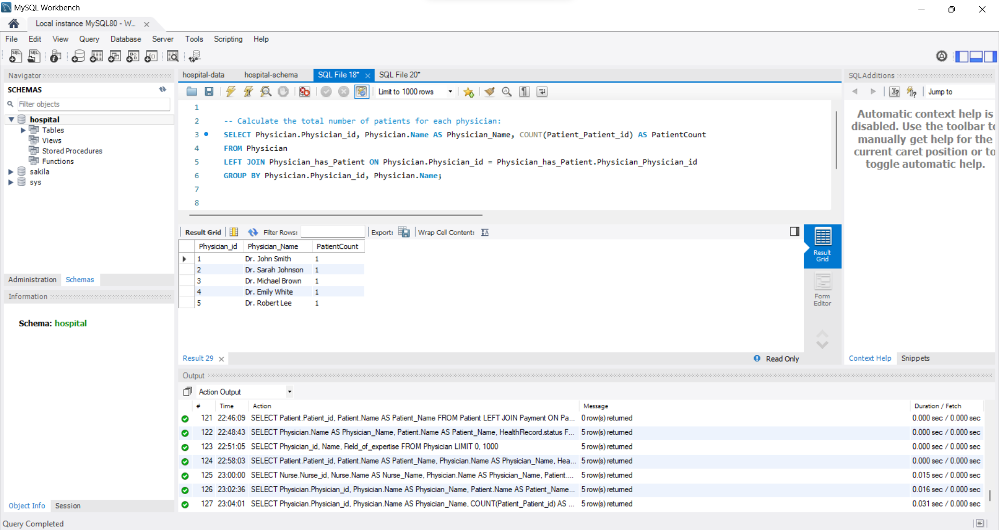

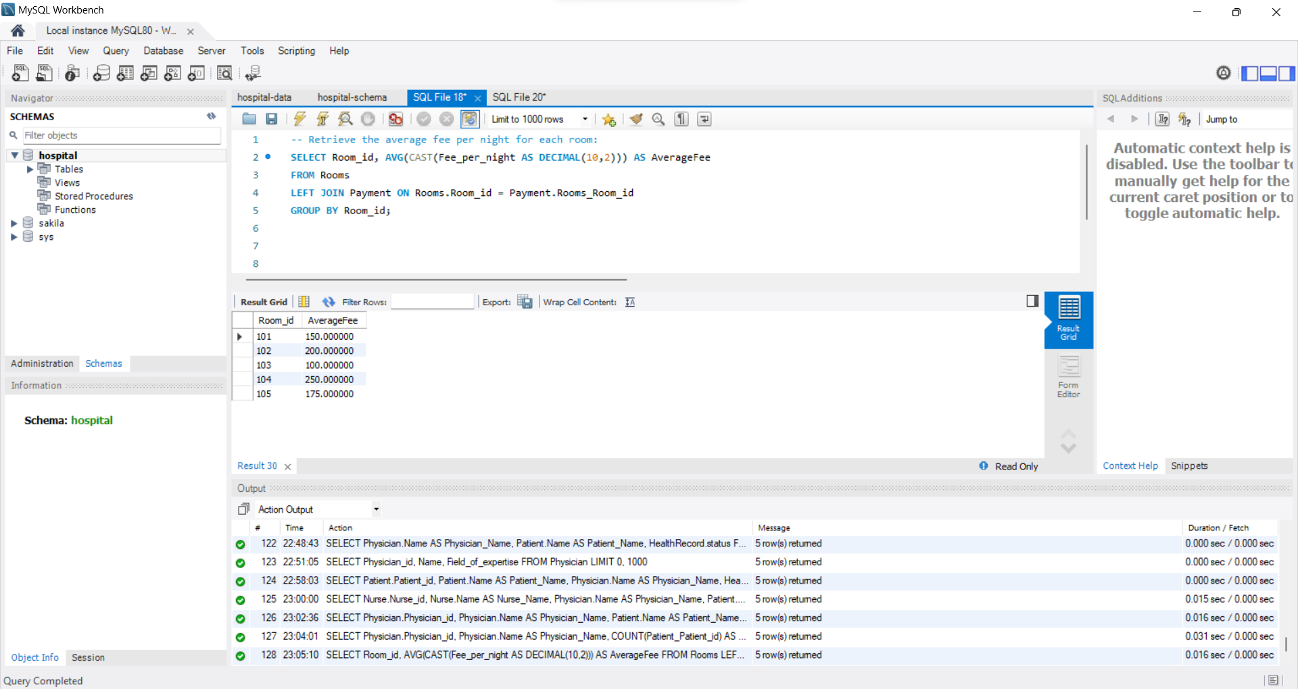

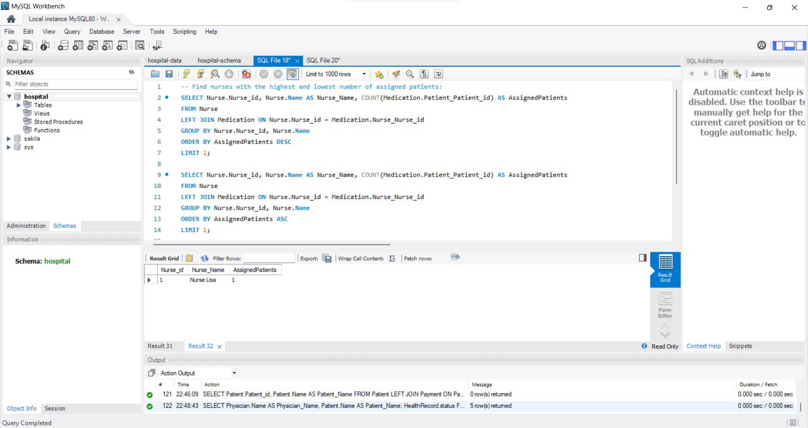

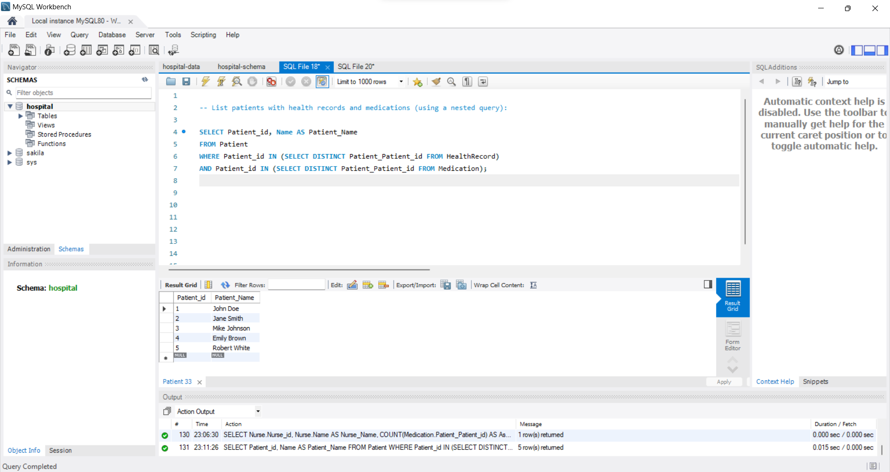

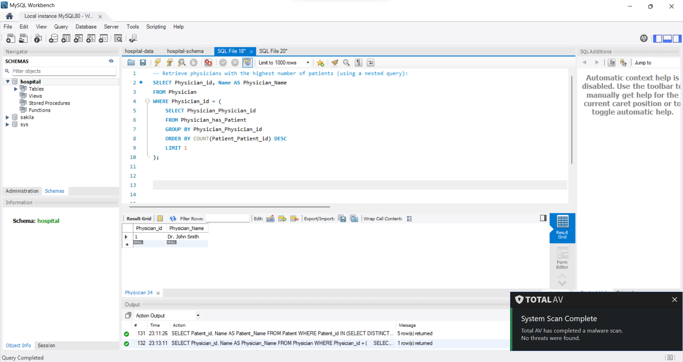

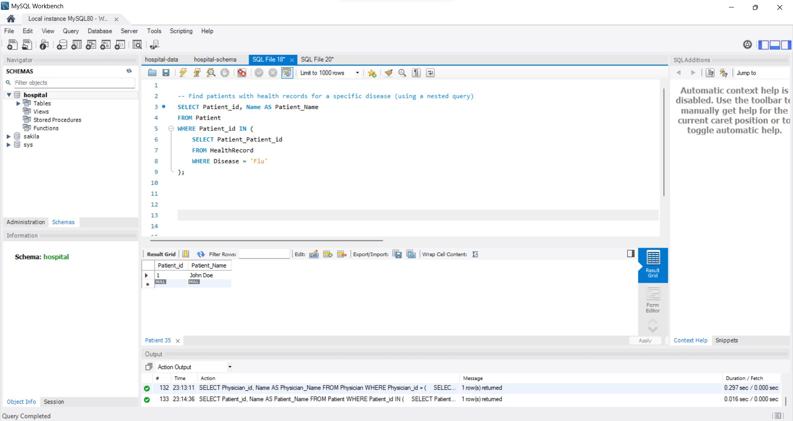

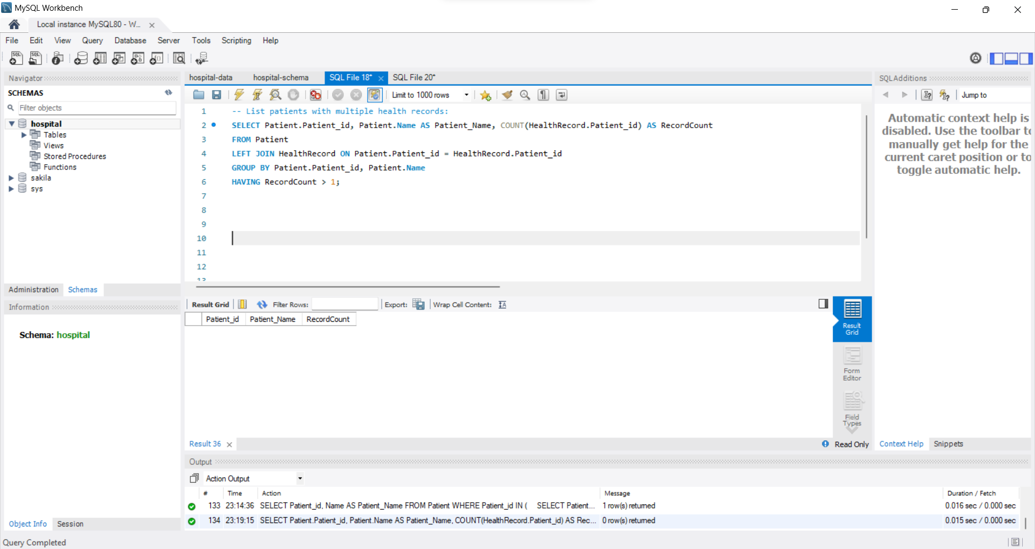

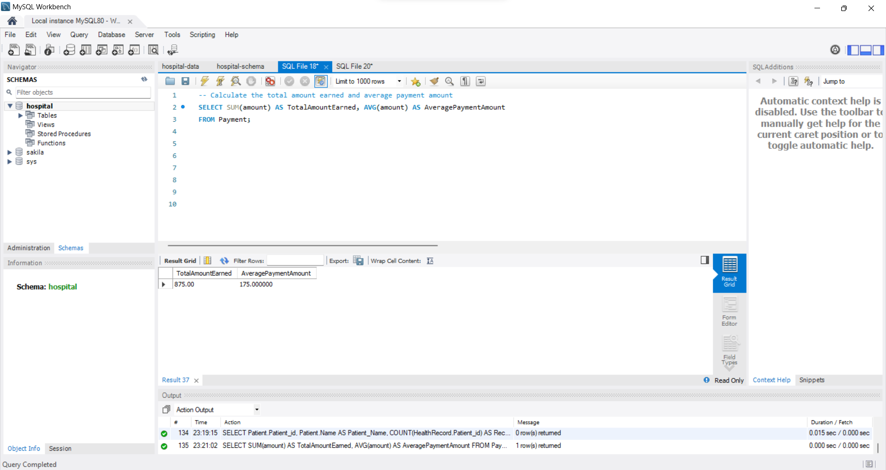

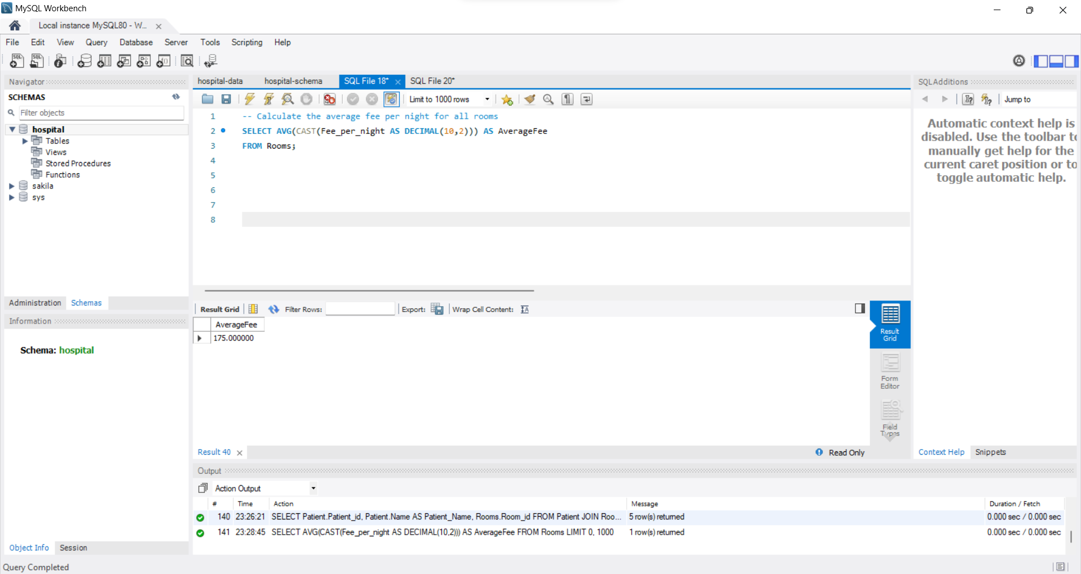

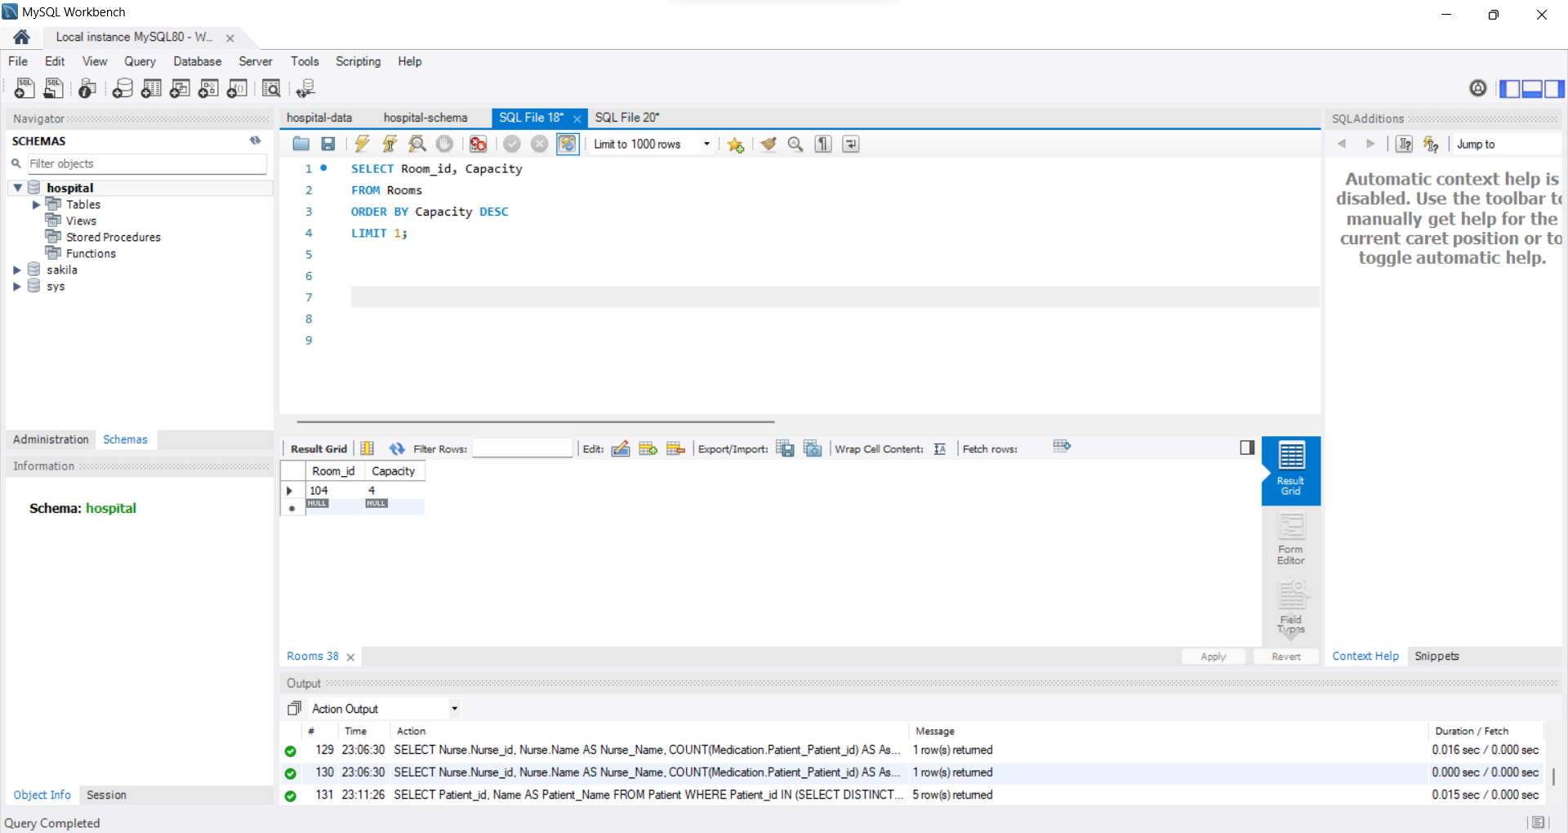

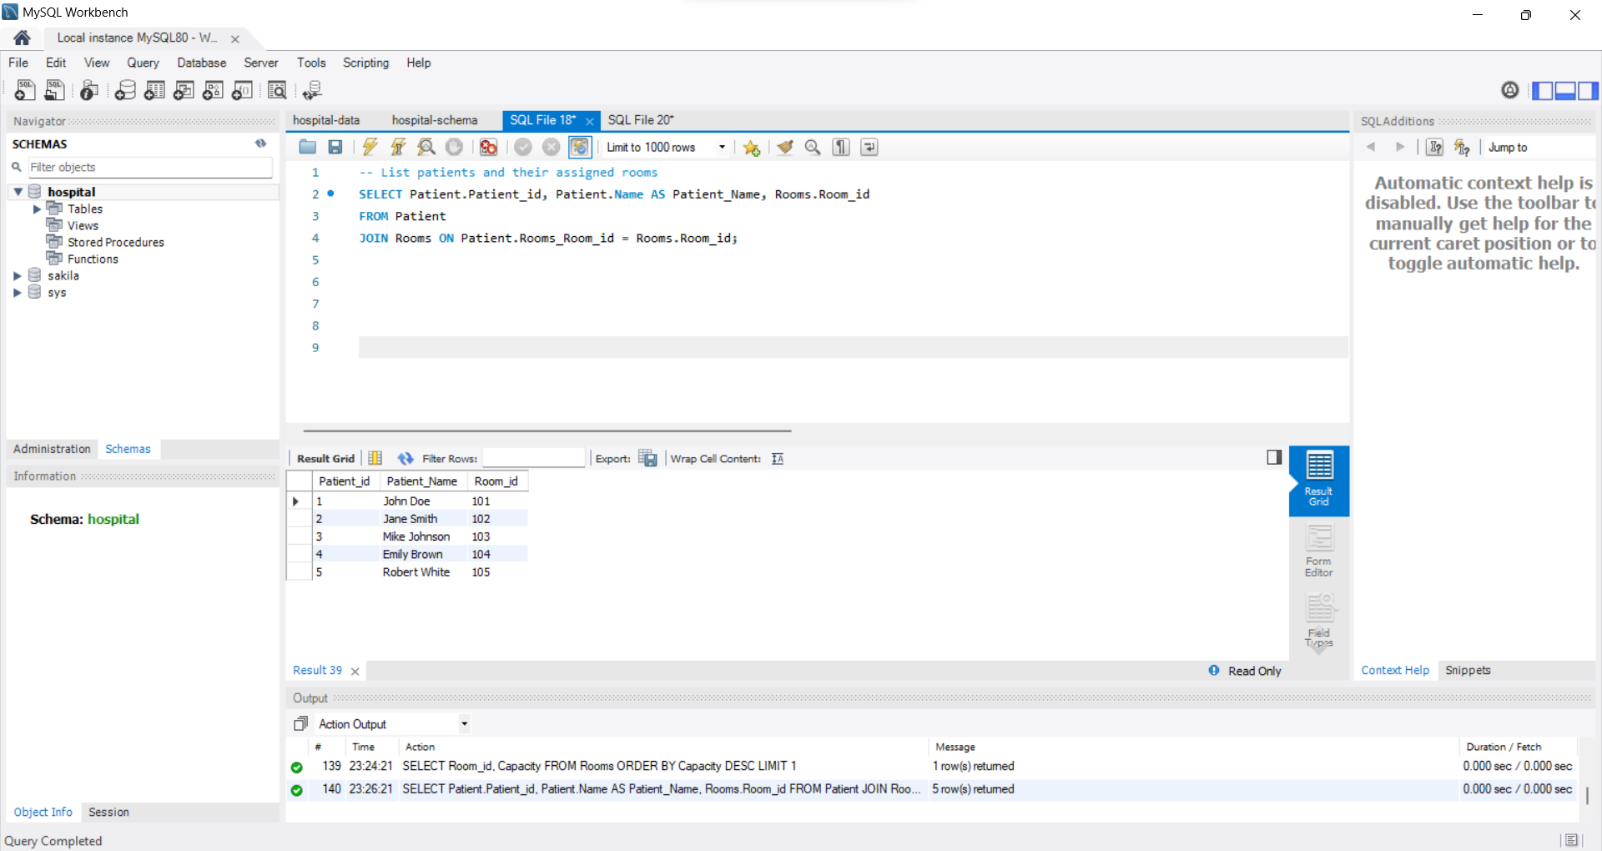

7- Transactions and description

AdmitPatientTransaction:

Description: A transaction to admit a new patient and record their health status simultaneously.

Body: A START TRANSACTION block with multiple SQL statements to insert into the Patient and HealthRecord tables.

Usefulness Discussion: Ensures the atomicity of the operation, preventing inconsistencies if either part of the transaction fails.

DischargePatientTransaction:

Description: A transaction to discharge a patient and update room occupancy.

Body: A START TRANSACTION block with SQL statements to delete from the Patient table and update the RoomOccupancyView.

Usefulness Discussion: Guarantees that both the patient deletion and room occupancy update occur together, maintaining data integrity.